ASSIGNMENT 12.5
Hall Ticket Number: 2303A51257
Name: SANGU UDAY

Task 1: Merge Sort Implementation
Algorithm Used: Merge Sort (Divide and Conquer)
Justification: Merge Sort provides O(n log n) time complexity in best, average, and worst cases. It is stable and suitable for large datasets.

Python Implementation :
def merge_sort(arr):
"""
Sorts a list in ascending order using Merge Sort.
Time Complexity:
Best Case: O(n log n)
Average Case: O(n log n)
Worst Case: O(n log n)
Space Complexity:
O(n)
"""
if len(arr) <= 1:
return arr
mid = len(arr) // 2
left = merge_sort(arr[:mid])
right = merge_sort(arr[mid:])
return merge(left, right)
def merge(left, right):
result = []
i = j = 0
while i < len(left) and j < len(right):
if left[i] < right[j]:
result.append(left[i])
i += 1
else:
result.append(right[j])
j += 1
result.extend(left[i:])
result.extend(right[j:])
return result
Code :
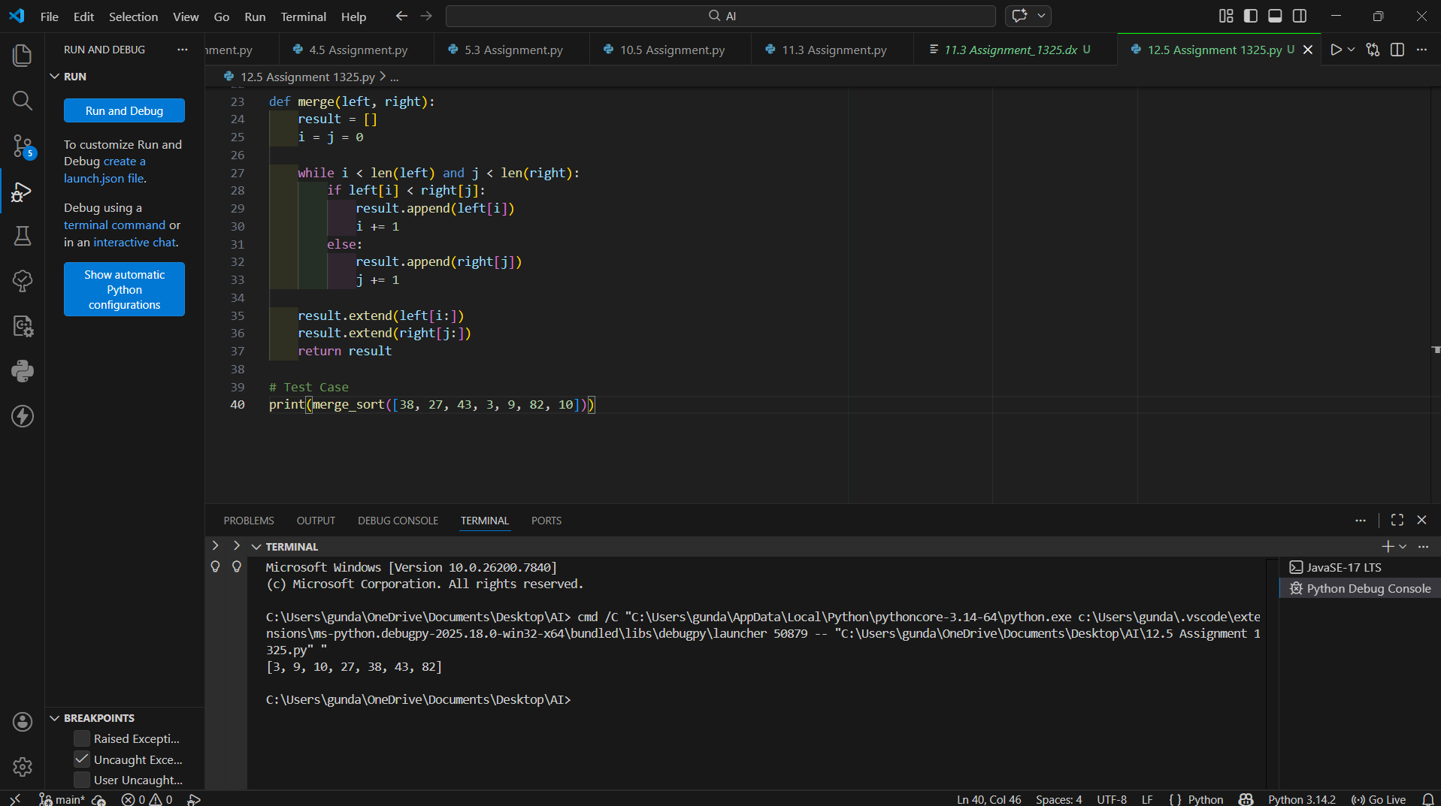

Task 2: Binary Search Implementation
Algorithm Used: Binary Search
Justification: Binary Search reduces search space by half each iteration and works in O(log n) time on sorted data.

Python Implementation:
def binary_search(arr, target):
"""
Searches for target in a sorted list.
Time Complexity:
Best Case: O(1)
Average Case: O(log n)
Worst Case: O(log n)
Space Complexity:
O(1)
"""
low = 0
high = len(arr) - 1
while low <= high:
mid = (low + high) // 2
if arr[mid] == target:
return mid
elif arr[mid] < target:
low = mid + 1
else:
high = mid - 1
return -1
Code :
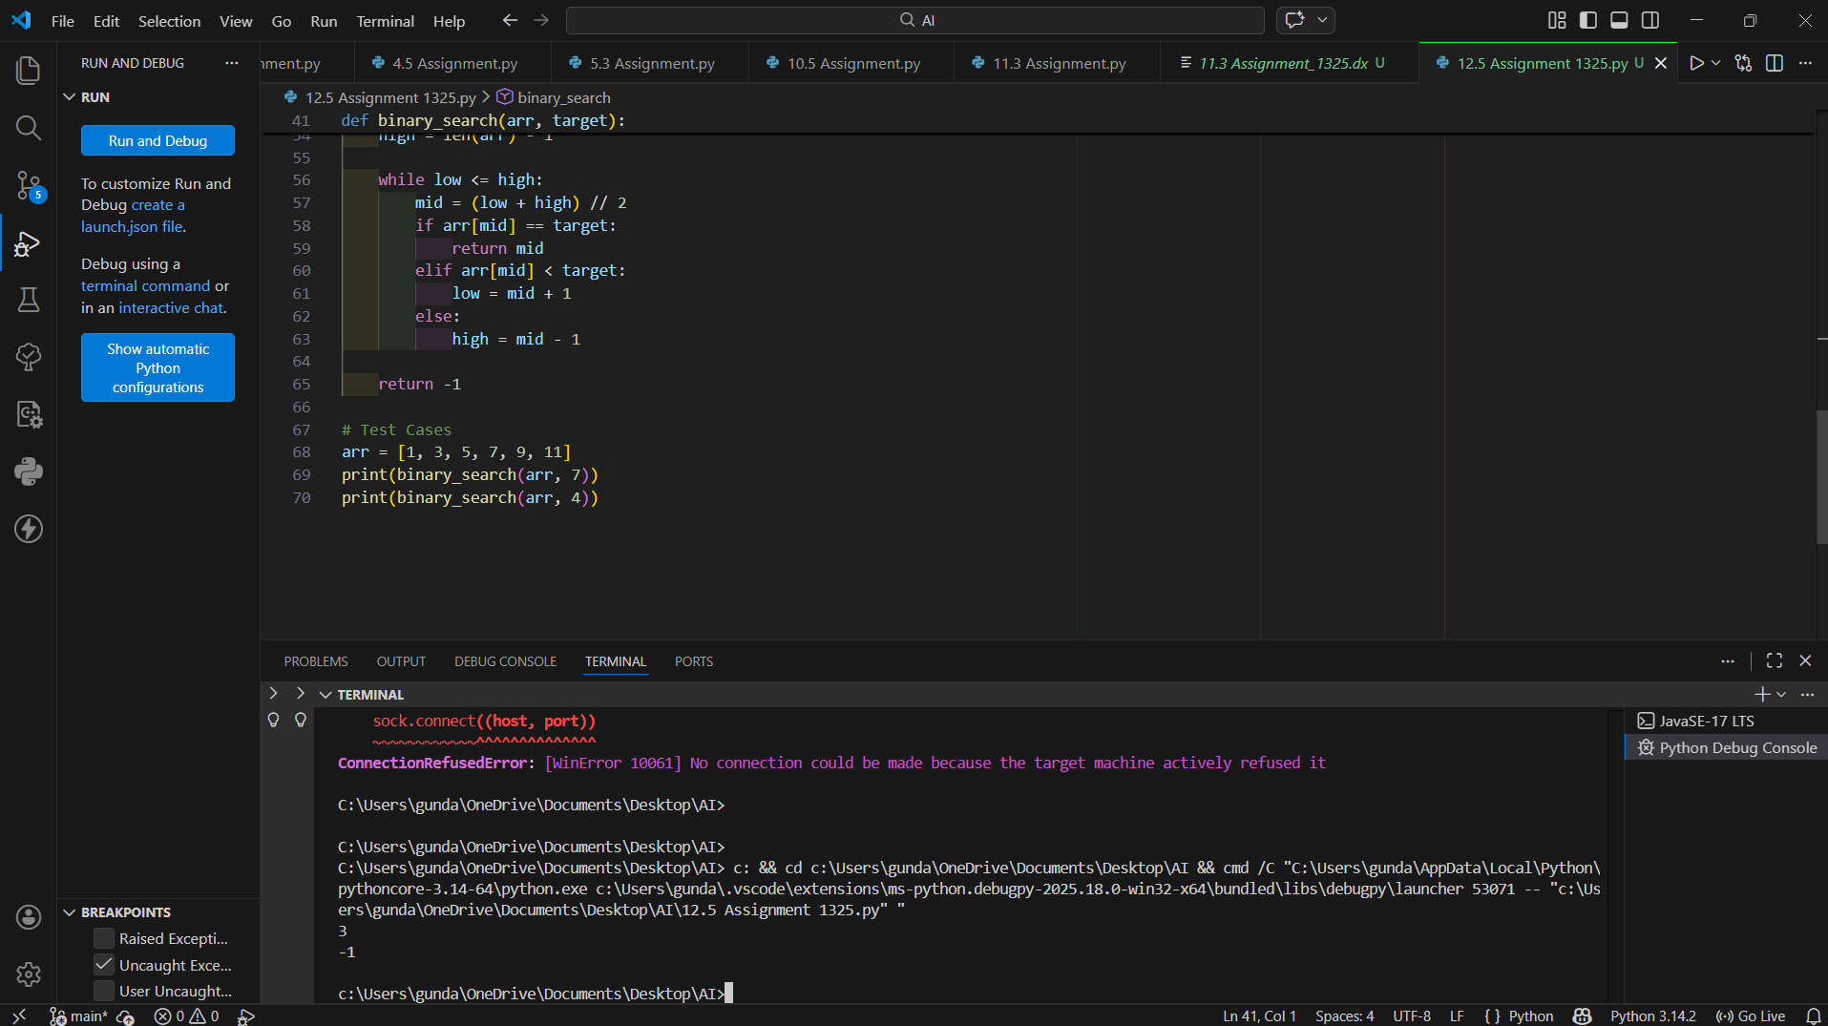

Task 3: Smart Healthcare Appointment Scheduling System
Selected Algorithms:
• Searching: Binary Search
• Sorting: Merge Sort / Python sorted()
Justification: Binary Search ensures fast lookup (O(log n)) when IDs are sorted. Merge Sort provides stable and efficient sorting (O(n log n)).
Implementation logic follows similar pattern of sorting records by key and applying binary search on IDs.
Code :
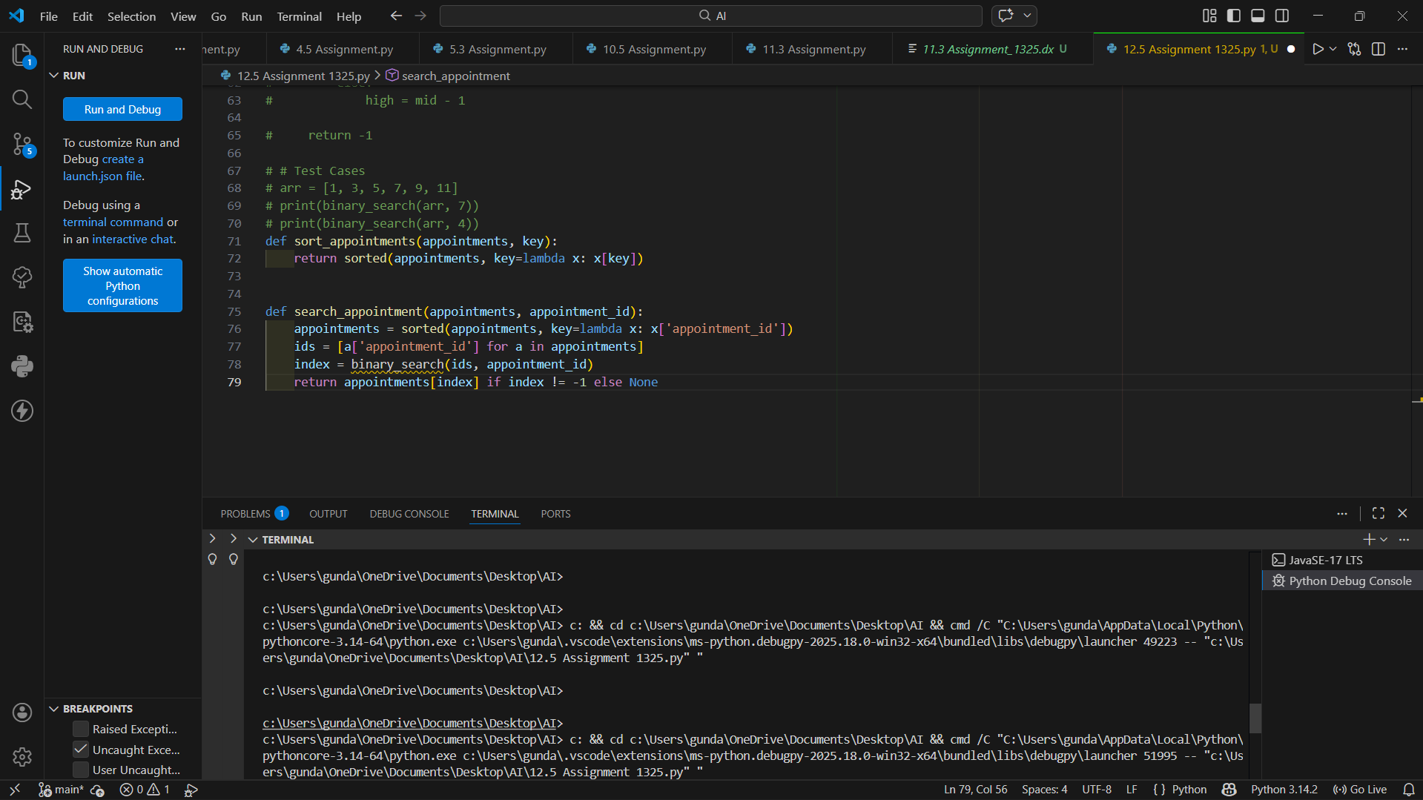

Task 4: Railway Ticket Reservation System
Selected Algorithms:
• Searching: Binary Search
• Sorting: Merge Sort / Python sorted()
Justification: Binary Search ensures fast lookup (O(log n)) when IDs are sorted. Merge Sort provides stable and efficient sorting (O(n log n)).
Implementation logic follows similar pattern of sorting records by key and applying binary search on IDs.
Code :
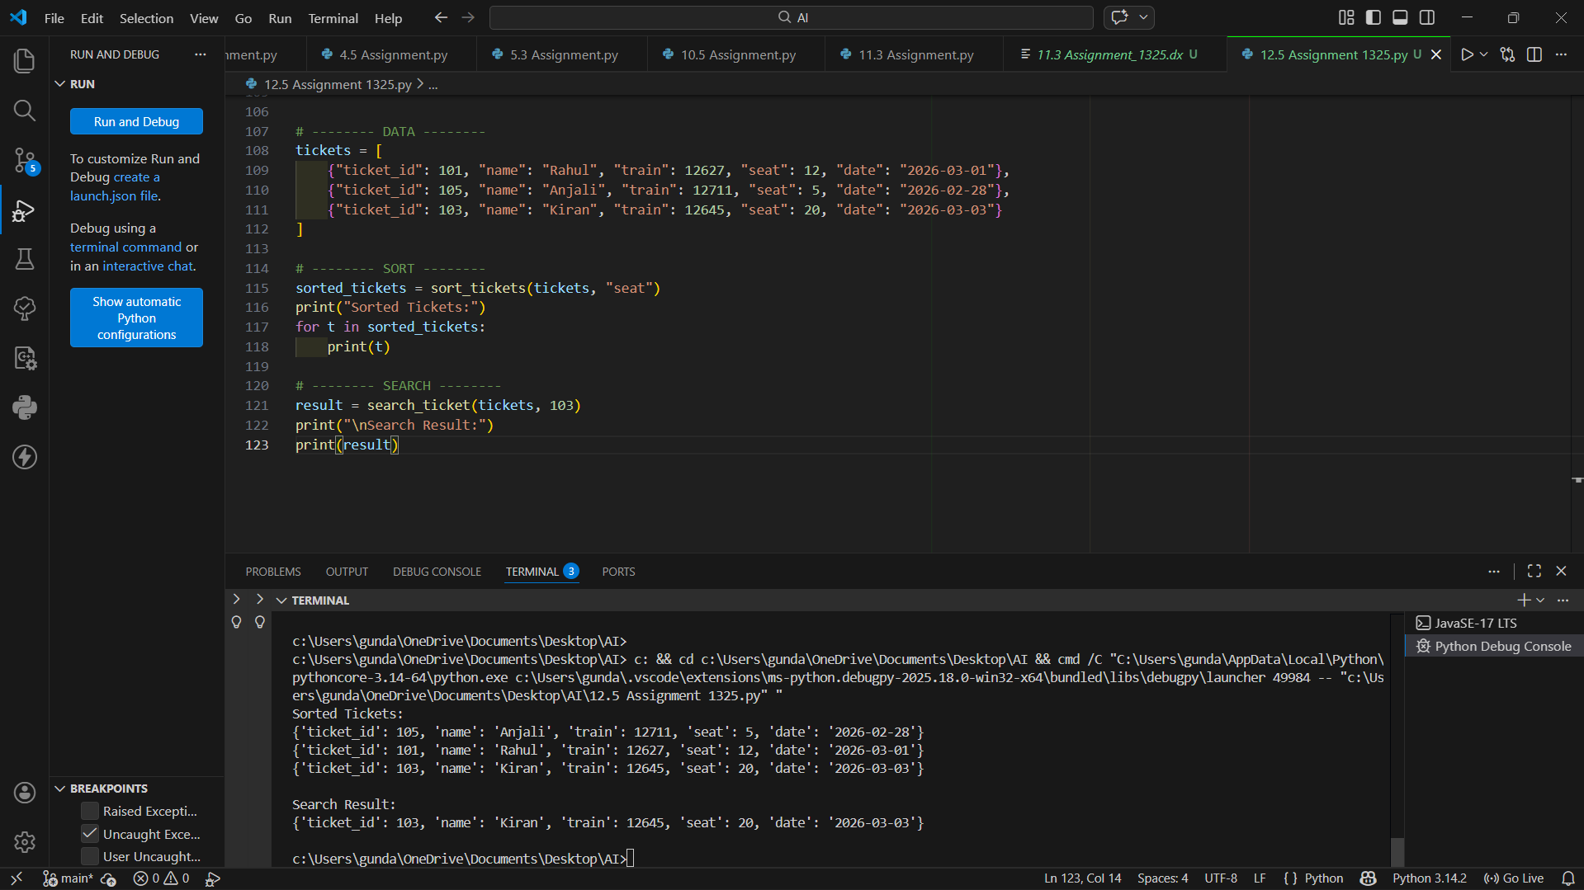

Task 5: Smart Hostel Room Allocation System
Selected Algorithms:
• Searching: Binary Search
• Sorting: Merge Sort / Python sorted()
Justification: Binary Search ensures fast lookup (O(log n)) when IDs are sorted. Merge Sort provides stable and efficient sorting (O(n log n)).
Implementation logic follows similar pattern of sorting records by key and applying binary search on IDs.
Code :
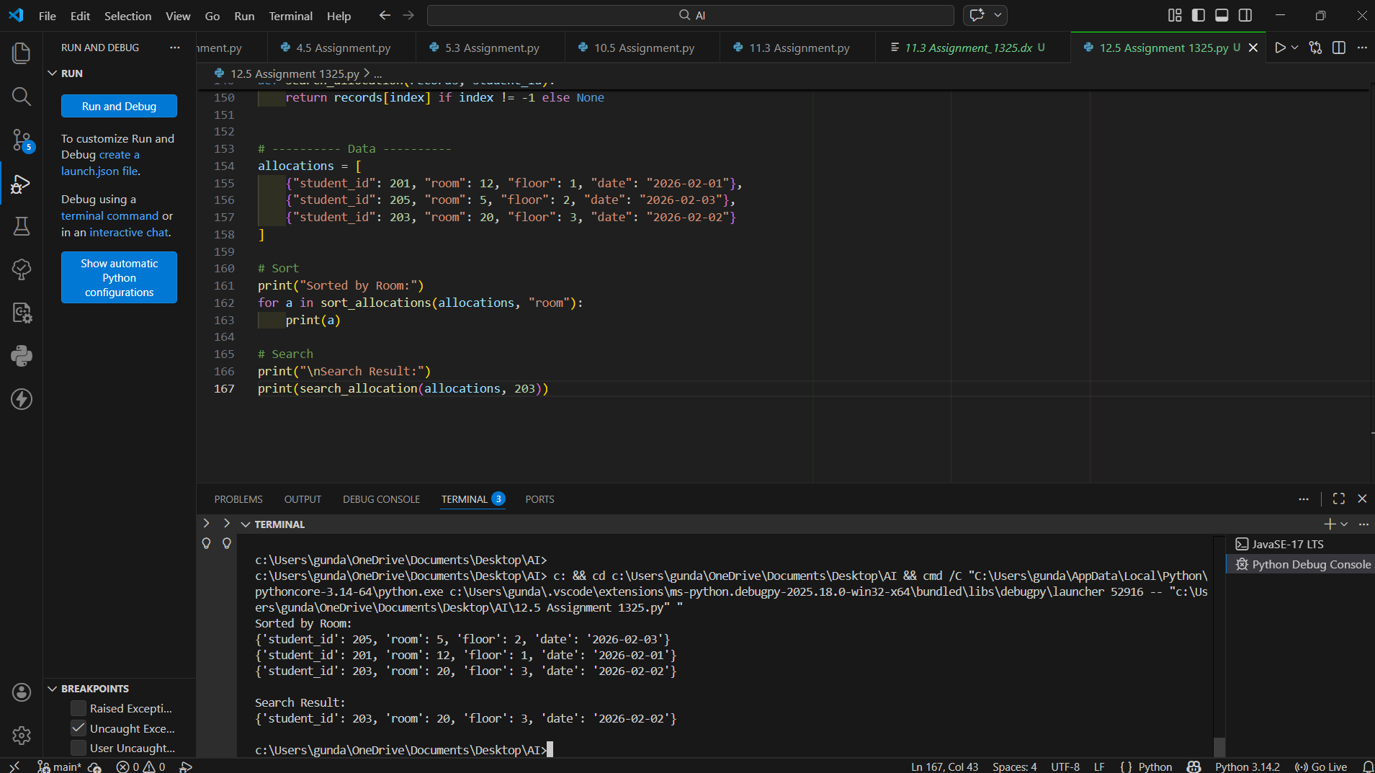

Task 6: Online Movie Streaming Platform
Selected Algorithms:
• Searching: Binary Search
• Sorting: Merge Sort / Python sorted()
Justification: Binary Search ensures fast lookup (O(log n)) when IDs are sorted. Merge Sort provides stable and efficient sorting (O(n log n)).
Implementation logic follows similar pattern of sorting records by key and applying binary search on IDs.
Code :
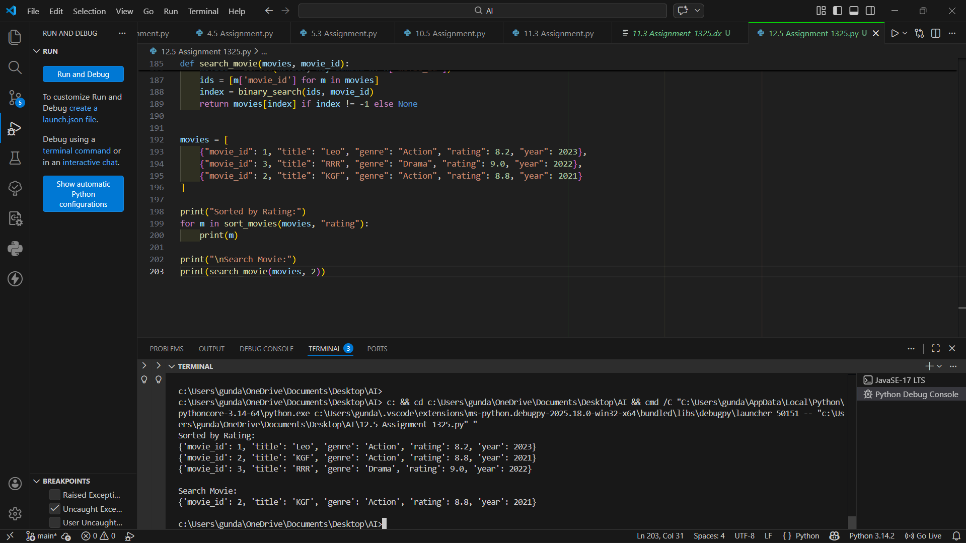

Task 7: Smart Agriculture Crop Monitoring System
Selected Algorithms:
• Searching: Binary Search
• Sorting: Merge Sort / Python sorted()
Justification: Binary Search ensures fast lookup (O(log n)) when IDs are sorted. Merge Sort provides stable and efficient sorting (O(n log n)).
Implementation logic follows similar pattern of sorting records by key and applying binary search on IDs.
Code :
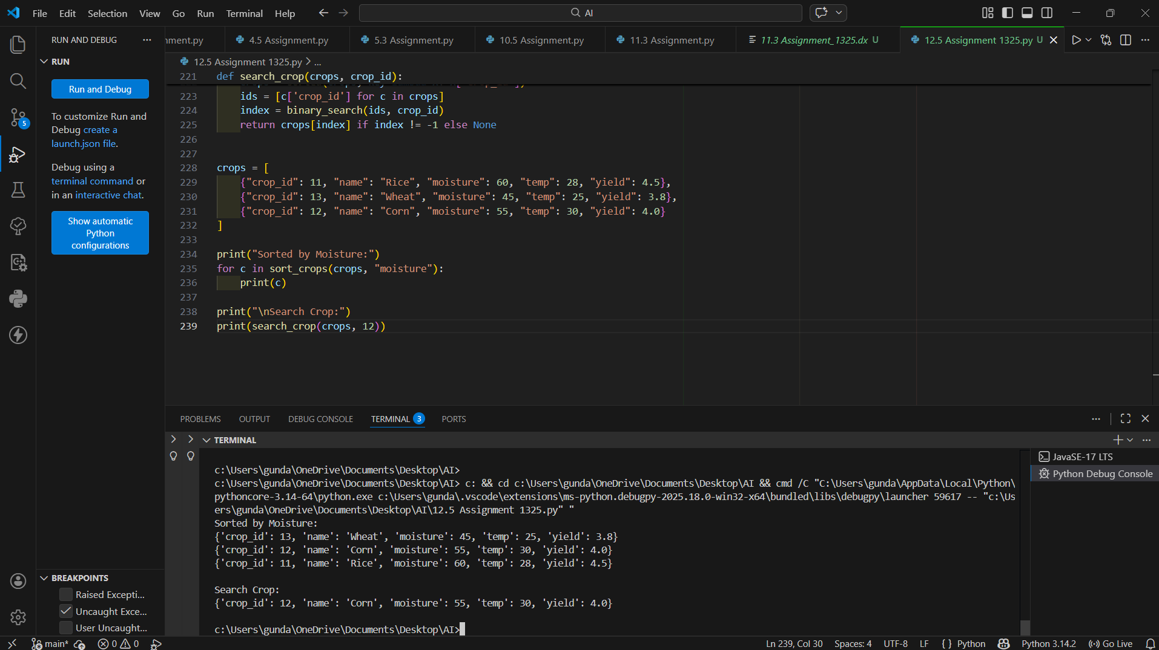

Task 8: Airport Flight Management System
Selected Algorithms:
• Searching: Binary Search
• Sorting: Merge Sort / Python sorted()
Justification: Binary Search ensures fast lookup (O(log n)) when IDs are sorted. Merge Sort provides stable and efficient sorting (O(n log n)).
Implementation logic follows similar pattern of sorting records by key and applying binary search on IDs.
Code :
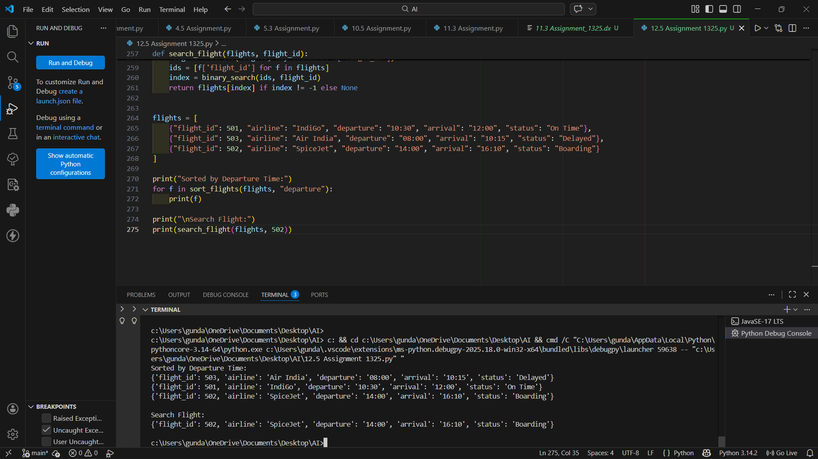

Conclusion
This assignment demonstrates implementation of efficient searching and sorting algorithms using AI assistance. Merge Sort and Binary Search were selected due to their optimal time complexities and suitability for structured data systems.

